Title: | Common Diagnosis Sub-System Entry Tool Instructions
References: | - Requirement Specification Common Diagnosis Sub-System  - Common Diagnosis Subsystem: Software Design Description  - Requirement Specification <CSV File Format Description>
Distribution | Development, Product Management, Quality Management, Industrial Engineering, Service, Project Leader
Author | Roberto Colombo | Date: 2007 February 19
Review | Product Management  Quality Management
Approved | R&D Management  Product Management  Industrial Engineering  Service  Supply Management  Project Leader
Remarks

Contents

1 Introduction 3
2 Design Concept – Code Generating 3
3 Prepare the project 4
4 Common Diagnosis Subsystem Entry Tool 5
4.1 Open Project 5
4.2 Project Control 5
4.3 Explorer Box 5
5 Common Diagnosis Configuration Process 6
5.1 Compiler Switches 6
5.2 Input-Output Subsystems 7
5.3 Output Conditions 8
5.4 Input Table 8
5.4.1 Input Table Constraint 8
5.5 Behaviuor Objects 9
5.6 Fast Output Table 9
6 Common Diagnosis Conditions Definition 10

Introduction

The Common Diagnosis Sub-System Entry Tool for the ABB Common Diagnosis Sub-System was developed with the intention to be able to create on a simple way the needed CSV-Files for the Common Diagnosis Sub-System code generator and to control the user input to reduce mistakes.
To simplify the CSV-File creation the Entry Tool provides a graphical user interface on which the user can create his Common Diagnosis Configuration. Additionally it provides the possibility to execute the code generators.
This document describes how the project should be prepared to be used with the Common Diagnosis Sub-System Entry Tool, with the code generators and it comprised a tutorial how the user can create the needed subsystem data.

Design Concept – Code Generating

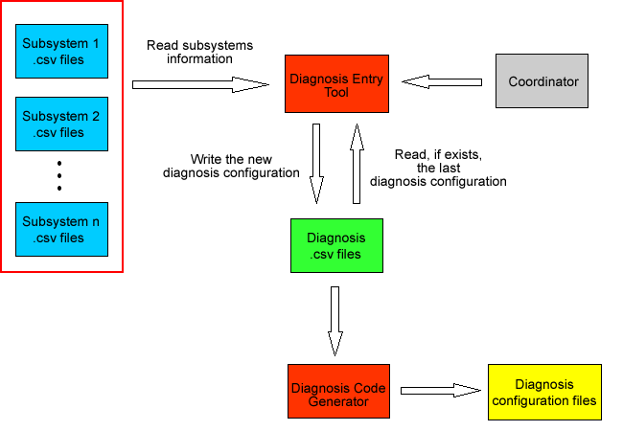

The Common Diagnosis Sub-System Entry Tool reads: subsystems csv - files, Coordinator information and the last Common Diagnosis Configuration from diagnosis CSV – files, if exists. The Common Diagnosis Sub-System Entry Tool save the new Common Diagnosis Configuration in the diagnosis CSV files. The Common Diagnosis Sub-System code generator expects diagnosis CSV – files as input and generates Diagnosis
Configuration files.

Prepare the project

To use the Common Diagnosis Sub-System Entry Tool with the code generator a project must be prepared as follow:
- The project shall be developped with the Entry Tool.
- Download the Common Diagnosis Sub-System code generator from Sharepoint (actual version 0.4) and insert it in the generators folder.
- Download the Common Diagnosis Sub-System Entry Tool from Sharepoint (actual version 0.4). The Entry Tool could lie on any path in the Windows file system e.g. also in the generators folder.
- The Common Diagnosis Sub-System Entry Tool was developed with the Microsoft .NET Framework 2.0. Without this MS-Framework the Common Diagnosis Sub-System Entry Tool could not be executed.
- The project shall contain a Coordinator Subsystem containing the Subsystem Indexes Enumeration (E_SUBSYSTEM_IDX) in the subsystem_idx.h file as shown in the figure below.

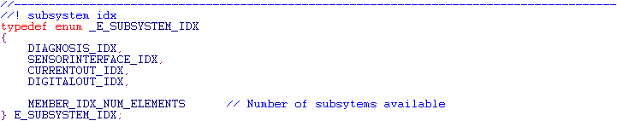
- The project shall contain a Common Diagnosis Subsystem (actual version 0.4).
- The project shall contain some input/output Subsystem as defined in [1].

Includere procedura inserimento T_DIAGNOSIS_ALARM nei cvs del framework e spiegare quali oggetti devono essere implementati.

Common Diagnosis Subsystem Entry Tool

Open Project
After starting Common Diagnosis Entry Tool, you can open a project by clicking on the Menu item Open. Select your path and click ok.

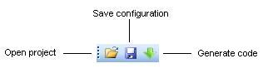

The Diagnosis Entry Tool checks the user selected path, that means if the chosen folder doesn’t include the Framework specified folders like generators, Diagnosis or Coordinator, then the Diagnosis Entry Tool shows an error message and the project would not be opened.

Project Control
After a project was successfully opened the user will see active the following commands:
- Save, which is used to save the diagnosis configuration.
- CodeGen, which is used to start the c code generation process.

Explorer Box

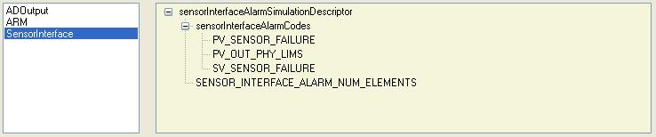

The explorer box shows the descriptors loaded from the subsystems included into the working project. It’s could be useful to check wheter the Common Diagnosis Entry Tools was able to load all the information needed to configure the Common Diagnosis Subsystem.

Common Diagnosis Configuration Process

Compiler Switches
The first part is used to configure the Common Diangosis Subsystem compiler switches, in order to fit the user preferencies and to exclude functions during the compiling process.

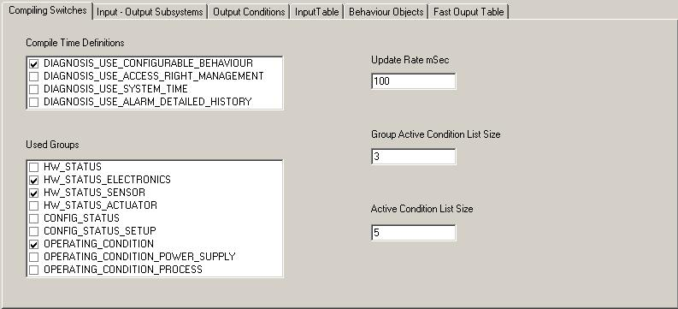

Compile Time Definitions:
- Configurable Behaviuor, this switch enable/disable the configurable behaviuor mechanism [1] used to define the output reaction to different diagnostic conditions or combination of them. If the switch is disabled the Behavoiur Object and the Fast Output Table Tabs are unaccessible.
- Access Right Management, this switch enable/disable the simulation rules defined in [1].
- Diagnosis Use System Time, this switch is used to link/unlink the diagnosis condition run time hour counter to the system time if avalable.
- Diagnosis Use Alarm Detailed History, this switch enable/disable the logging of the input alarm conditions. This feature is in addition to the simple alarm history and to the alarms details.

Used Groups, this switch is used to configure which groups are used by the device as sources of diagnosis conditions.

Update Rate mSec, represents the update rate for the Common Diagnosis UpdateDeviceStatusEXE method. It is used to update the diagnosis condition run time hour counter when the system time is not available.

Group Active Condition List Size, set the size of the list returned by the GetActiveDiagnosticConditionsSRV method when the request is about one group.

Active Condition List Size, set the size of the list returned by the GetActiveDiagnosticConditionsSRV method when the request is all groups.

Input-Output Subsystems
The Input-Output Subsystem Tab is used to choose which subsystems are input, output or input/output for the Common Diagnosis Subsystem.

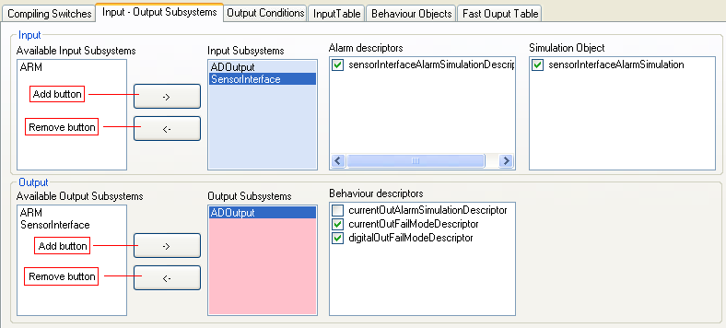

Define an Input Subsystem:
- Get from the available input subsystem list all the subsystems that are inputs for the Common Diagnosis Subsystem though the add button.
- For each subsystem in the Input Subsystems list select a:
  - Alarm Descriptor, that is imported into the Common Diagnosis Subsystem and used to construct the alarm object related to the subsystem.
  - Simulation Object, that is used by the Comon Diagnosis Subsystem to drive Subsystem’s alarm simulation [2].
To remove a subsystem from the Input Subsystems use the remove button.

Define an Output Subsystem:
- Get from the available output subsystem list all the subsystems that are outputs for the Common Diagnosis Subsystem though the add button.
- For each subsystem in the Output Subsystems list select a:
  - Behaviour Descriptor, that is imported into the Common Diagnosis Subsystem and used to construct the behaviour objects related to the subsystem.
To remove a subsystem from the Output Subsystems use the remove button.

Output Conditions

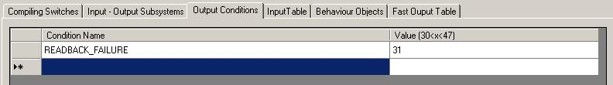

In the Output Condition tab you can define your device specific diagnosis conditions that you will use in the Input Table configuration. Diagnosis subsystem has some common diagnosis conditions (see Common Diagnosis Conditions Definition) already defined, the device specific diagnosis condition values must be between 128 and 254.

Input Table
Input Table contains all the information about how the diagnosis subsystem shall produce output.

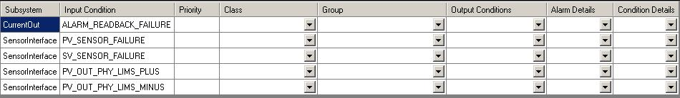

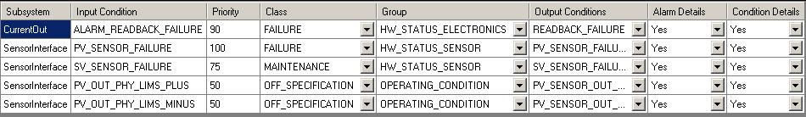

The table is partially completed, the entry tool fills automatically the first two columns with the conditions coming from the alarm descriptor choosen in Input-Output Subsystems Tab.
For each row the user shall add the priority, the class, the group, the output condition (refer to [1] for details), record details and condition details.

Input Table Constraint

If the Common Diagnosis Entry Tool user is not able to complete the Input Table, the Entry Tool and the Code Generator will produce the code if requested. A warning will be displayed remembering the user which rows are empty.

If two different input condition produce the same output condition they shall have the same priority, class and group. A check function has been implemented into the Entry Tool and will produce an error if a misconfiguration is detected.

Behaviuor Objects
In this section you can create your alarm behaviour objects, that store the reaction of a FAST response subsystem related to a specific alarm condition. If the Configurable Behaviuor flag in Compiler Switches is unchecked this section is unavailable.

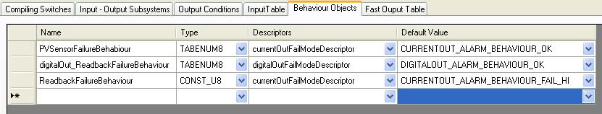

Each row represent a behavoiur object and it is composed by:
- Name, the name of the alarm behaviour object.
- Type, the data type of the alarm behaviour object. It could be an enumeration (TABENUM8) if the behaviuor is configurable, or a constant (CONST_U8) if the behaviour is a constant one.
- Descriptor, represent the object descriptor in case the object is an enumaration or the value possible choices in case the object is a constant one.
- Default value, is the object default value when it is an enumerated data type or the value if it is a constant one.

Fast Output Table
Fast Output Table contains all the information about how the diagnosis subsystem shall drive output subsystem in the fast task execution [1].

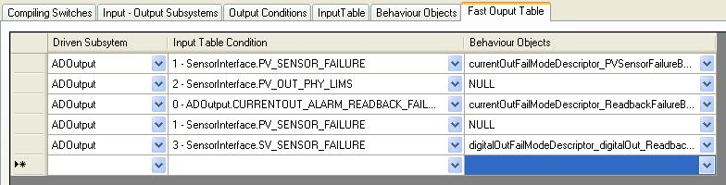

Each row represent the reaction of an output subsystem to an alarm condition:
- Driven Subsystem, is the subsystem the fast path has to drive.
- Input Condition, is the alarm condition that drive the subsystem during the fast path.
- Behaviuor Object, is the link to the Behaviuor Object that stores the reaction of the driven subsystem. If the driven subsystem has not its own Behaviuor Object set it to NULL, the value will be automatically choose by the Common Diagnosis Subsystem the two values defined in diagnosis.h file.

Common Diagnosis Conditions Definition

 | MNEMONIC | TYPE OF ERROR | TYPE OF DETECTION
SENSOR | PV_SENSOR_FAILURE | Primary variable sensor failure | Device specific
SENSOR | PV_SENSOR_FAILURE | Primary variable sensor failure | Device specific
SENSOR | SV_SENSOR_FAILURE | Secondary variable sensor failure | Device specific
SENSOR | SV_SENSOR_FAILURE | Secondary variable sensor failure | Device specific
SENSOR | TV_SENSOR_FAILURE | Tertiary variable sensor failure | Device specific
SENSOR | TV_SENSOR_FAILURE | Tertiary variable sensor failure | Device specific
SENSOR | FV_SENSOR_FAILURE | Fourth variable sensor failure | Device specific
SENSOR | FV_SENSOR_FAILURE | Fourth variable sensor failure | Device specific
SENSOR | PV_SENSOR_OUT_LIMS | Primary variable out of limits | PV > Sensor Limit Hi
SENSOR | PV_SENSOR_OUT_LIMS | Primary variable out of limits | PV < Sensor Limit Lo
SENSOR | SV_SENSOR_OUT_LIMS | Secondary variable out of limits | SV > Sensor Limit Hi
SENSOR | SV_SENSOR_OUT_LIMS | Secondary variable out of limits | SV < Sensor Limit Lo
SENSOR | TV_SENSOR_OUT_LIMS | Tertiary variable out of limits | TV > Sensor Limit Hi
SENSOR | TV_SENSOR_OUT_LIMS | Tertiary variable out of limits | TV < Sensor Limit Lo
SENSOR | FV_SENSOR_OUT_LIMS | Fourth variable out of limits | FoV > Sensor Limit Hi
SENSOR | FV_SENSOR_OUT_LIMS | Fourth variable out of limits | FoV < Sensor Limit Lo
APPLICATION | PV_SENSOR_OUT_RANGE | Primary variable out of range | PV > Range Limit Hi
APPLICATION | PV_SENSOR_OUT_RANGE | Primary variable out of range | PV < Range Limit Lo
APPLICATION | SV_SENSOR_OUT_RANGE | Secondary variable out of range | SV > Range Limit Hi
APPLICATION | SV_SENSOR_OUT_RANGE | Secondary variable out of range | SV < Range Limit Lo
APPLICATION | TV_SENSOR_OUT_RANGE | Tertiary variable out of range | TV > Range Limit Hi
APPLICATION | TV_SENSOR_OUT_RANGE | Tertiary variable out of range | TV < Range Limit Lo
APPLICATION | FV_SENSOR_OUT_RANGE | Fourth variable out of range | FoV > Range Limit Hi
APPLICATION | FV_SENSOR_OUT_RANGE | Fourth variable out of range | FoV < Range Limit Lo
FRONT END | FE_BOARD_FAILURE | Front End Board Failure | ROM CRC  ResponseTimeout
FRONT END | FE_NV_FAILURE | Front End NvMem Failure | CRC Check
FRONT END | FE_NV_WARNING | Front End NvMem Warning | EEPROM write cycles exceeded
FRONT END | FE_BOARD_NOT_DETECTED | Front End Not Detected | No Startup Communication
FRONT END | FE_BOARD_COMM_ERROR | Front End Communication Error | Data CRC  Framecounter
NV | CB_NV_FAILURE | Communication Board NvMem Failure | CRC Check
NV | CB_NV_WARNING | Communication Board NvMem Warning | EEPROM write cycles exceeded
NV | NV_STORAGE_ACTIVE | NV storage active
NV | NV_CONCISTENCY_CHECK | EEPROM Consistency Check | NV Failures states, repair

Revision Chart

Rev. | Description of Version/Changes | Primary Author(s) | Date
0.4 | First Draft (the revision start from 0.4 to keep this document consistent with other Common Diagnosis Documents) | Roberto Colombo | 2007 March 19

